**08/05/2020 - Week 1**

**Attendance: Paul and Brendan**

List of stakeholders:

* Customer
* Relationship Manager (RM)
* Project Developer
* Profiler - don't need to make an empathy map for the software components
* Target list
* Call distributor

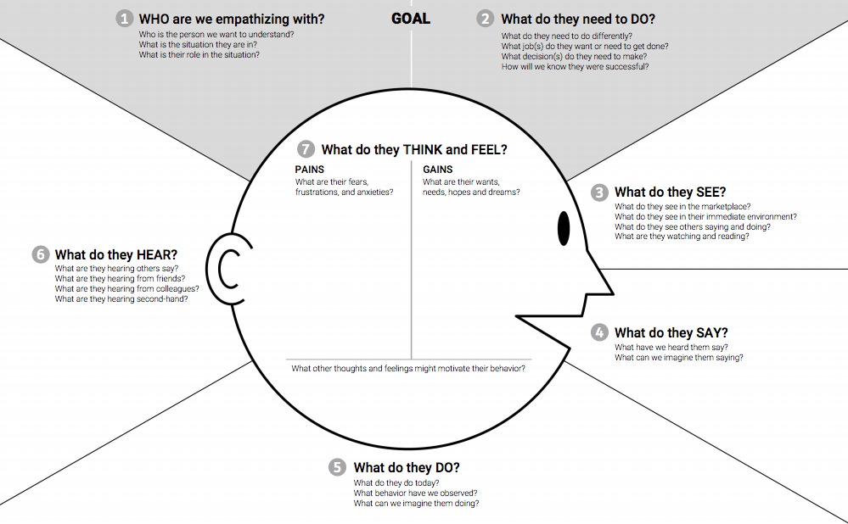

**Customer**

1. Customers are current users and potential buyers. Customers wish to have an expeditious process when they purchase holiday packages.
2. Customers hope to be matched with an appropriate RM, so that they can purchase an appropriate holiday package. Customers decide their price range or budget, accommodation, destination, itinerary. Customers know they are successful when they have purchased a holiday package
3. Customers will see advertisements or brochures. Customers will see confirmation from the travel company of the details of their trip. Customers do not see the backend of the process. They are also seeing reviews of various holiday packages
4. Customer dialogue consists of requests, questions and confirmation.
5. Customers browse brochures and advertisements, as well as conduct personal research and purchase holiday packages.
6. Customers hear referrals and recommendations from their friends/colleagues. They also hear a personal, tailored recommendation from RMs
7. Pains: General travel anxieties, lengthy buying process, out-of-budget prices and being recommended an inadequate holiday package.
8. Gains: Quick buying process, more-than-adequate holiday, affordable prices
9. Motivations: Going on a holiday, getting a perceived cheap deal

**Relationship Manager**

1. Relationship managers are the person we want to empathise with. They perform sales of holiday packages.
2. They need to sell packages and provide an appropriate holiday package to the customer. Acquire new buyers as well. Maintain current working relationship with customers. They need to tailor the correct package to each customer’s unique needs. We know that they are successful when they meet/exceed KPIs.
3. They see the profiler tool matching them with customers, see the customer profile. They see other RMs pitching a package. They would be reading a script?
4. They read off a script to persuade a customer. They recommend different additional options, try to upsell.
5. Fill out a questionnaire which assesses their skills. Sell holiday packages. Log the call after a sale has been completed. Send off the package details to the customer.
6. Hear customer needs, hear tips & complaints from colleagues.
7. Pains: Under-performing customers, difficult customers, stingy customers, fear of redundancy.
8. Gains: Exceeding sales, promotion, travel discounts, make money.
9. Motivations: Money, satisfaction of setting up a holiday for a customer

**Project Developer**

1. Project developers develop the system/project.
2. Develop a working system using agile principles in a timely manner. Prioritising certain functions, identify stakeholder needs.
3. Project developers see comparable products in the market. Project developers are seeing elicited requirements from stakeholders.
4. They discuss with RMs about their needs. They ask customers what they want. Have scrum meetings, discuss with the team about project details.
5. Project developers are doing activities that are within the scope of their current sprint. These activities would include, but are not limited to: developing, designing and testing
6. Project developers hear complaints about the current system, receive feedback. They would also hear feedback from colleagues.
7. Pains: Not meeting deadlines, inefficiencies, difficult clients, uninformed stakeholders
8. Gains: Educated stakeholders, exceeding deadlines, working, agile software
9. Motivations: Money, pleasure from developing software

**Questions:**

* Do RMs have to personally book flights and accommodation, or is it handled by a third party?
* Ghassan answered: No, assume that they are handled by a third-party.